Whitewater Rafting Website Plan.

Branding.

Logo.

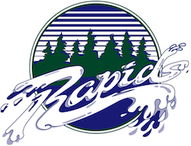

Style Guide.

Color Schema.

Color palette URL: [*coolors.co/042325-04414e-406348-cbe4c9*](https://coolors.co/042325-04414e-406348-cbe4c9) .

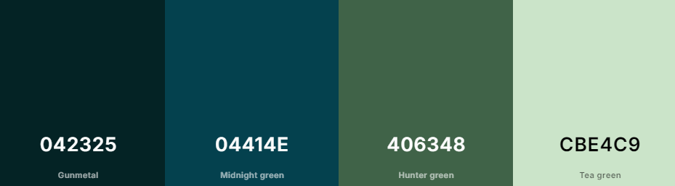

* Primary color: #042325.
* Secondary color: #CBE4C9.
* Accent color one: #04414E.
* Accent color two: #406348.

Typography.

Headings: Times New Roman.

Body: Verdana.